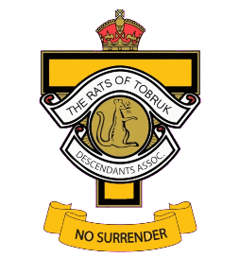
DESCENDANTS OF THE RATS OF TOBRUK AUSTRALIA ASSOCIATION Inc.
Registration for 80th Anniversary Reunion 22-24 October, 2021

Please forward this registration form together with payment to:
The Secretary, DOTROTA, PO BOX 3389, Victoria Point West, Qld. 4165.
or email to: dotrota41@gmail.com

FIRST ATTENDEE:

…………. …………………………………………………………………………… ………………………………………………………………………………..
Title Given Name (s) Surname

Address: …………………………………………………………………………………………………………………………………………………………………………………

……………………………………………………………………………………………….. …………………………… ………………………..
State Postcode

Email: …………………………………………………………………………………………………………….. Phone No: ………………………………….
Please Print Clearly
SECOND ATTENDEE: If more than two persons please attach another form with names. Total payment can be made here.

…………. …………………………………………………………………………… ………………………………………………………………………………..
Title Given Name (s) Surname

OTHER ATTENDEES:

…………. …………………………………………………………………………… ………………………………………………………………………………..
Title Given Name (s) Surname

…………. …………………………………………………………………………… ………………………………………………………………………………..
Title Given Name (s) Surname

Will you be attending the Sunday Service? YES NO
Your DOTROTA Membership No. ……………………..
Please print your Soldier’s details below:
……………………………………………………………………………………………..… ……………………………………..…………………………………………
Given Name (s) Surname
……………………………………………….. …………………………………………………………………………………………. ………………………………………
Service No. Unit Date of Death

Payment Details:

$95 per person includes Saturday Dinner and Sunday Refreshments. (Friday evening at own expense)

Payment can be made by Cheque, EFTPOS, Credit Card, Money Order or Cash. For EFTPOS, please include a unique reference so that the payment can be matched to the registration. e.g. ‘REGO’ and your surname.

Bank Account Details: Account Name: DOTROTA BSB: 124-001 Account No.22920417
The EFT ‘reference’ I have used is: |R|E|G|O|_|_|_|_|_|_|_|_|_|_|_|_|_|_|_|

Payment by Credit Card:
Number |_|_|_|_|_|_|_|_|_|_|_|_|_|_|_|_| Expiry Date ……/……./….... CVV……..

